Bangladesh Medical Association (BMA)
List of Life Member-126
18. BMA Feni Branch

Sl No | Voter No | Voter Details
1 | Voter No  LM-1800001  No Image | DR. ABUL QUASEM CHOWDHURY  F/Name: Late Haji Md. Miah Chowdhury  M/Name:  BM & DC Reg. No:  NID:  Cell:  Address: Vill.& P.O. Kadalpur P.S- Raozan, Chittagong.  Blood Group:  E X P I R E D
2 | Voter No  LM-1800002  No Image | DR. MUZIBUL HUQ  F/Name: Late Haji Wahidur Rahman  M/Name:  BM & DC Reg. No:  NID:  Cell:  Address: Shaheen Clinic Ltd. 55, Kaisar Road Feni.  Blood Group:
3 | Voter No  LM-1800003  No Image | DR. MD. SHAMSUL HOQUE  F/Name: Dr. Md. Shamsul Hoque  M/Name:  BM & DC Reg. No:  NID:  Cell:  Address: Civil Surgeon, Feni.  Blood Group:  E X P I R E D
4 | Voter No  LM-1800004  No Image | DR. DAWOODUL ISLAM  F/Name: Late Abdul Aziz  M/Name:  BM & DC Reg. No:  NID:  Cell:  Address: Master Para, Feni.  Blood Group:  E X P I R E D
5 | Voter No  LM-1800005  No Image | DR. MD. ASADULLAH FARUQ  F/Name: Late Abul Hossain Rahmani  M/Name:  BM & DC Reg. No:  NID:  Cell:  Address: Senior Consultant Surgery (Ex) Sadar Hospital, Feni.  Blood Group:  E X P I R E D
6 | Voter No  LM-1800006  No Image | DR. MD. GOFRANUL HUQE  F/Name:  M/Name:  BM & DC Reg. No:  NID:  Cell:  Address: Senior Consultand Medicine Sadar Hospital Feni.  Blood Group:
7 | Voter No  LM-1800007  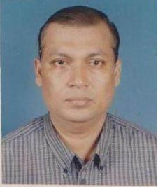 | DR. MD. ANWAR HOSSAIN  F/Name: Abdur Rob  M/Name:  BM & DC Reg. No:  NID:  Cell:  Address: Sadar Hospital, Feni.  Blood Group:
8 | Voter No  LM-1800008  No Image | DR. MOHAMMED SHAHABUDDIN  F/Name: Late Israfil Miah  M/Name:  BM & DC Reg. No:  NID:  Cell:  Address: Upazila Health & F.P Officer Parashuran UPHC., Feni.  Blood Group:  E X P I R E D
9 | Voter No  LM-1800009  No Image | DR. MD. ALI HALDER  F/Name:  M/Name:  BM & DC Reg. No:  NID:  Cell:  Address: Doctor Para, Feni.  Blood Group:  E X P I R E D
10 | Voter No  LM-1800010  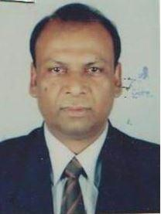 | DR. A.S.M. TABAROK ULLAH CHOWDHURY (BAYZIED)  F/Name: Late Azamullah Chowdhury  M/Name:  BM & DC Reg. No:  NID:  Cell:  Address: Baizid's Health Service Centre Trunk Road Feni.  Blood Group:
11 | Voter No  LM-1800011  No Image | DR. HAZERA KHATUN  F/Name:  M/Name:  BM & DC Reg. No:  NID:  Cell:  Address:  Blood Group:  TRANSFERED to BMA Dhaka City  LM-1405543
12 | Voter No  LM-1800012  No Image | DR. MD. FAZLUR RAHMAN  F/Name:  M/Name:  BM & DC Reg. No:  NID:  Cell:  Address:  Blood Group:  TRANSFERED to BMA Dhaka City  LM-1405543
13 | Voter No  LM-1800013  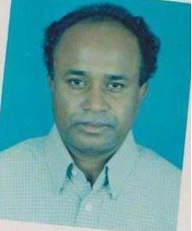 | DR. A..F.M MOZAMMEL HOQUE  F/Name: Saydul Hoque  M/Name:  BM & DC Reg. No:  NID:  Cell:  Address: Sadar Hospital Feni.  Blood Group:
14 | Voter No  LM-1800014  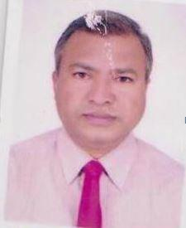 | DR. MD. FAIZUL BARI  F/Name: Sk. Abdul Pazir  M/Name:  BM & DC Reg. No:  NID:  Cell:  Address: UH&FPO UPHC, Dagonbhuiyan Feni.  Blood Group:
15 | Voter No  LM-1800015  No Image | DR. MOHAMMAD SHAHAJAHAN CHODDHURY  F/Name: Salamoth Ullah Chowdhury  M/Name:  BM & DC Reg. No:  NID:  Cell:  Address: Cosmopolyton Hospital Ltd. Comilla Bus Stand Feni.  Blood Group:
16 | Voter No  LM-1800016  No Image | DR. QUAZI ISMAIL AMANULLAH KASEM  F/Name: Quazi Md. Siddique Ullah  M/Name:  BM & DC Reg. No:  NID:  Cell:  Address: Academy Road, Feni.  Blood Group:  E X P I R E D
17 | Voter No  LM-1800017  No Image | DR. ZAINUL ABDIN  F/Name: Haji Amanullah  M/Name:  BM & DC Reg. No:  NID:  Cell:  Address: Mohipal, Feni.  Blood Group:
18 | Voter No  LM-1800018  No Image | DR. TAZUN NAHAR  F/Name: Tomkin Uddin Ashraful Alam  M/Name:  BM & DC Reg. No:  NID:  Cell:  Address: Marie Stopes Clinic Feni SSK Road Feni.  Blood Group:
19 | Voter No  LM-1800019  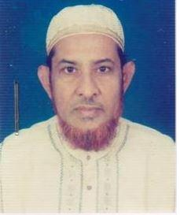 | DR. MUHAMMAD IQBAL HUSSAIN  F/Name: Late A.m. Rouf  M/Name:  BM & DC Reg. No:  NID:  Cell:  Address: 429, Nazir Road Feni  Blood Group:
20 | Voter No  LM-1800020  No Image | DR. HASINA MOMATAJ  F/Name:  M/Name:  BM & DC Reg. No: 13603  NID:  Cell:  Address: Feni  Blood Group:  TRANSFERED to BMA Dhaka City  LM-1405543
21 | Voter No  LM-1800021  No Image | DR. MUZIBUR RAHMAN  F/Name:  M/Name:  BM & DC Reg. No:  NID:  Cell:  Address:  Blood Group:  TRANSFERED to BMA Dhaka City  LM-1405543
22 | Voter No  LM-1800022  No Image | DR. AKLIMA AKHTER BANU  F/Name:  M/Name:  BM & DC Reg. No:  NID:  Cell:  Address:  Blood Group:  TRANSFERED to BMA Dhaka City  LM-1405543
23 | Voter No  LM-1800023  No Image | DR. JAHANARA BEGUM  F/Name: Late Anwar Ullah  M/Name:  BM & DC Reg. No:  NID:  Cell:  Address: S.S.K. Road Feni.  Blood Group:
24 | Voter No  LM-1800024  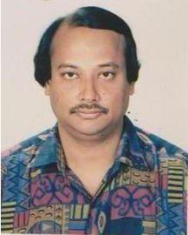 | DR. MD. NURUL ALAM  F/Name: Late Abdus Samad  M/Name:  BM & DC Reg. No:  NID:  Cell:  Address: Panchgasia Road, Feni.  Blood Group:
25 | Voter No  LM-1800025  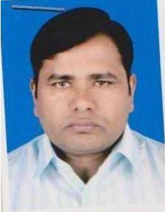 | DR. MD. NUR ULLAH  F/Name: Md. Muzibul Hoque  M/Name:  BM & DC Reg. No:  NID:  Cell:  Address: Sonagazi Clinic, Sonagazi, Feni.  Blood Group:
26 | Voter No  LM-1800026  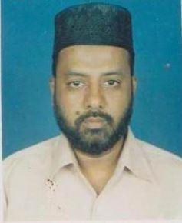 | DR. NUR MOHAMMAD  F/Name: Late Prof. Nurul Absar  M/Name:  BM & DC Reg. No:  NID:  Cell:  Address: 530, Mizan Road, Feni.  Blood Group:
27 | Voter No  LM-1800027  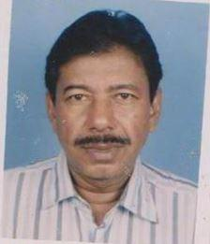 | DR. MD. AYUB ALI  F/Name: Late Md. Rabon Ali  M/Name:  BM & DC Reg. No:  NID:  Cell:  Address: Alisa Bhaban Acadamy Road Feni.  Blood Group:
28 | Voter No  LM-1800028  No Image | DR. NAHIDA NAZNIN  F/Name: Md. Mainuddin Shikder  M/Name:  BM & DC Reg. No:  NID:  Cell:  Address: Medical Officer, (Clinic) Maternal & Child Welfare Centre Feni  Blood Group:
29 | Voter No  LM-1800029 | DR. MD. ABDUL KADER  F/Name: Hafez Ahmed  M/Name:  BM & DC Reg. No:  NID:  Cell:  Address: Mediscan Ltd. S.S.K Road, Feni.  Blood Group:
30 | Voter No  LM-1800030  No Image | DR. A.K.M ABUL HOSSAIN  F/Name:  M/Name:  BM & DC Reg. No:  NID:  Cell:  Address:  Blood Group:  TRANSFERED to BMA Dhaka City  LM-1405543
31 | Voter No  LM-1800031  No Image | DR. A.K. M SHOWKAT HOSSAIN TIPU  F/Name: Late Dr. A.k. M.tofazzal Hossain  M/Name:  BM & DC Reg. No:  NID:  Cell:  Address: 222, Kamal Hazari Road, Academy, Feni.  Blood Group:  E X P I R E D
32 | Voter No  LM-1800032  No Image | DR. BIDYUT BHUSHAN DAS GUPTA  F/Name: Late Benoy Bhushan Das Gupta  M/Name:  BM & DC Reg. No:  NID:  Cell:  Address: R.M.O Diabetes Hospital Feni.  Blood Group:
33 | Voter No  LM-1800033  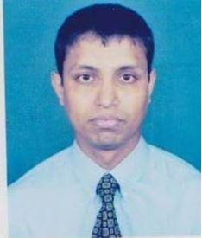 | DR. MD. SHAHIDUL ISLAM  F/Name: Dr. Md. Ali Ashraf  M/Name:  BM & DC Reg. No:  NID:  Cell:  Address: 102, Master Para, Feni.  Blood Group:
34 | Voter No  LM-1800034  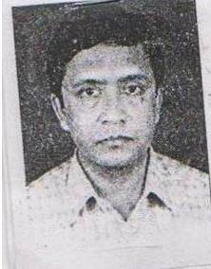 | DR. F.M. MOFAKHARUL ISLAM  F/Name: Dr. A.f.m Samsul Islam  M/Name:  BM & DC Reg. No:  NID:  Cell:  Address: Doctor Para, Feni.  Blood Group:
35 | Voter No  LM-1800035  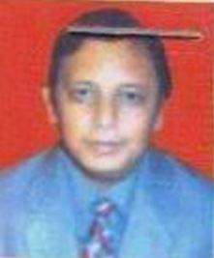 | DR. NEAZ MAHMUD HAIDER  F/Name: Late Md. Nurul Huda Chowdhury  M/Name:  BM & DC Reg. No:  NID:  Cell:  Address: Feni Surgical Care Clinic, Academy Road, Feni.  Blood Group:
36 | Voter No  LM-1800036 | DR. ALAUDDIN MAZUMDER  F/Name: Md. Nazir Ahmed  M/Name:  BM & DC Reg. No:  NID:  Cell:  Address: Upazila Health Complex Chhagalnaiya, Feni.  Blood Group:
37 | Voter No  LM-1800037  No Image | DR. MD. AMIR HOSSAIN  F/Name: Late Munsar Ali  M/Name:  BM & DC Reg. No:  NID:  Cell:  Address: UH&FPO, Sonagazi UPHC Feni  Blood Group:
38 | Voter No  LM-1800038  No Image | DR. MALAY KANTI CHAKRABORTY  F/Name:  M/Name:  BM & DC Reg. No:  NID:  Cell:  Address:  Blood Group:  TRANSFERED to BMA Dhaka City  LM-1405543
39 | Voter No  LM-1800039  No Image | DR. MD. HUMAYUN KABIR  F/Name: Md. Belayet Hossain  M/Name:  BM & DC Reg. No:  NID:  Cell:  Address: Medical Officer Chest Diseases Clinic, Feni.  Blood Group:  E X P I R E D
40 | Voter No  LM-1800040  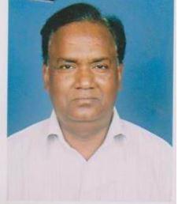 | DR. MD. ROWSAN ALI BHUIYAN  F/Name: Late Charu Miah Bhuiyan  M/Name:  BM & DC Reg. No:  NID:  Cell:  Address: Consultant, ENT Sadar Hospital Feni  Blood Group:
41 | Voter No  LM-1800041 | DR. MD. SARWAR JAHAN  F/Name: ATM Mofazzal Hoque  M/Name:  BM & DC Reg. No:  NID:  Cell:  Address: RMO, Sadar Hospital, Feni  Blood Group:
42 | Voter No  LM-1800042  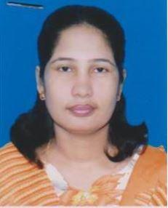 | DR. S.M. ABDULLAH AL MAMUN  F/Name: Md. Abdul Khaleque Advocate  M/Name:  BM & DC Reg. No:  NID:  Cell:  Address: D.D, Family Planning Dept. Feni  Blood Group:
43 | Voter No  LM-1800043 | DR. MRS. NARGIS SULTANA  F/Name: Md. Enamul Haque  M/Name:  BM & DC Reg. No:  NID:  Cell:  Address: Jr. Consultant(Gynae) Fulgazi UPHC Feni  Blood Group:
44 | Voter No  LM-1800044  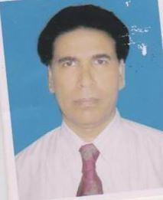 | DR. KM NURUL ABSAR  F/Name: Late Ibrahim Hossain  M/Name:  BM & DC Reg. No:  NID:  Cell:  Address: Resident Medical Officer, Chagalnaiya Health Complex, Feni.  Blood Group:
45 | Voter No  LM-1800045  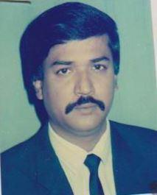 | DR. MANZUR IQBAL  F/Name: Late Khaiz Ahmed  M/Name:  BM & DC Reg. No:  NID:  Cell:  Address: Ahmed Villa, Doctor Para, Feni  Blood Group:
46 | Voter No  LM-1800046  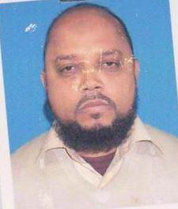 | DR. ABDUL MOMIN  F/Name: Shafiqul Haider  M/Name:  BM & DC Reg. No:  NID:  Cell:  Address: Al-Kamy Hospital SSK Road Feni.  Blood Group:
47 | Voter No  LM-1800047  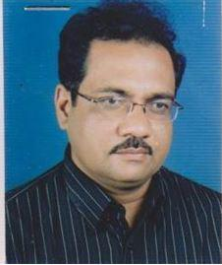 | DR. SHAHEDUL ISLAM BHUIYAN (KAOSAR)  F/Name: Anwar Ullah Bhuiyan  M/Name:  BM & DC Reg. No:  NID:  Cell:  Address: Concept Health Care Clinic Trunk Road, Feni.  Blood Group:
48 | Voter No  LM-1800048 | DR. JAHANARA AKTAR (RUMA)  F/Name: Md. Abdul Hai  M/Name:  BM & DC Reg. No:  NID:  Cell:  Address: Concept Health Care Clinic Trunk Road Feni.  Blood Group:
49 | Voter No  LM-1800049  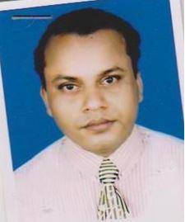 | DR. MD. SHEHAB UDDIN  F/Name: Md. Tofazzal Hussain  M/Name:  BM & DC Reg. No:  NID:  Cell:  Address: Islamia General Hospital, SSK Road, Feni.  Blood Group:
50 | Voter No  LM-1800050  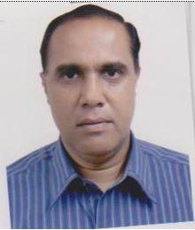 | DR. ABDUL HALIM  F/Name: Late Nurul Hoq  M/Name:  BM & DC Reg. No:  NID:  Cell:  Address: Consultant, Medicine Sadar Hospital Feni  Blood Group:
51 | Voter No  LM-1800051  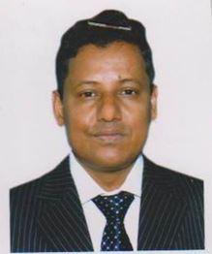 | DR. ABUL KHAIR MIAZI  F/Name: Late Serajul Haque Miazi  M/Name:  BM & DC Reg. No:  NID:  Cell:  Address: Chhagalnaiya Health Complex Chhagalnaiya Feni  Blood Group:
52 | Voter No  LM-1800052  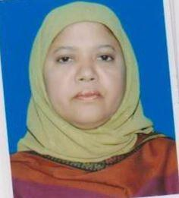 | DR. MAHBUBA KHANUM  F/Name: Prof. Mofizul Islam  M/Name:  BM & DC Reg. No:  NID:  Cell:  Address: Jr. Consultant, Gynae & Obs. Upazila Health Complex Dagonbhuiyan Feni  Blood Group:
53 | Voter No  LM-1800053  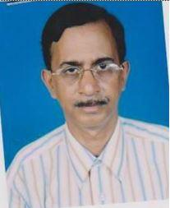 | DR. RAM PADA SAHA  F/Name: Late Gopi Nath Saha  M/Name:  BM & DC Reg. No:  NID:  Cell:  Address: Godown Quarter Feni.  Blood Group:
54 | Voter No  LM-1800054  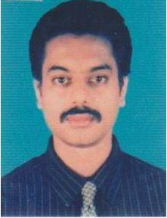 | DR. BURHANUDDIN AHMED SADIQ  F/Name: Saifulddin Ahmed  M/Name:  BM & DC Reg. No:  NID:  Cell:  Address: Upazila Health Complex Chhagalnaiya Feni  Blood Group:
55 | Voter No  LM-1800055  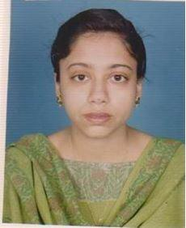 | DR. SHUMNA AKHTER AZAD  F/Name: Shamsul Azad Chowdhury  M/Name:  BM & DC Reg. No:  NID:  Cell:  Address: Upazila Health Complex Chhagalnaiya Feni  Blood Group:
56 | Voter No  LM-1800056  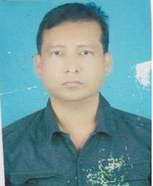 | DR. MD. ZAHARNGIR ALAM CHOWDHURY  F/Name: Md. Rustam Mia  M/Name:  BM & DC Reg. No:  NID:  Cell:  Address: Consultant, Eye Sadar Hospital Feni.  Blood Group:
57 | Voter No  LM-1800057  No Image | DR. MD. NURUL ALAM  F/Name: Late Goni Ahammad  M/Name:  BM & DC Reg. No:  NID:  Cell:  Address: Fulgazi Upazila Health Complex Munshir Hat Feni.  Blood Group:
58 | Voter No  LM-1800058  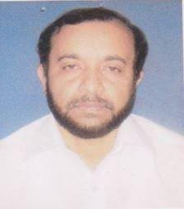 | DR. A.M.M. SAIF UDDIN  F/Name: Late Mvi. Abul Khair  M/Name:  BM & DC Reg. No:  NID:  Cell:  Address: T.B. Seg. Hospital, Feni.  Blood Group:
59 | Voter No  LM-1800059  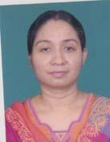 | dR. JOYA PAUL  F/Name: Biswanath Paul  M/Name: Swapna Paul  BM & DC Reg. No: 35151  NID: 3022910103168  Cell: 01711152329  Address: Upasham General Hospital S.S.K Road, Feni  Blood Group: B+
60 | Voter No  LM-1800060  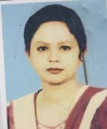 | dR. ROKSHANA AKTHER  F/Name: Abdur Rashid Bhuiyan  M/Name: Akter Bhanu  BM & DC Reg. No: 37180  NID: 1213338215956  Cell: 01711985465  Address: 289, Kathal Bagan, Dhaka-1205  Blood Group: A+
61 | Voter No  LM-1800061 | DR. SREEKANTA CHAKRABORTY  F/Name: Satya Ranjan Chakraborty  M/Name: Lila Rani Chakraborty  BM & DC Reg. No: 30783  NID: 3014167688605  Cell: 01553647873  Address: Feni Diabetes Hospital, Mizan Road. feni.  Blood Group: O+
62 | Voter No  LM-1800062 | DR. SUKANTA CHANDRA DAS  F/Name: Arun Chandra Das  M/Name: Monju Rani Das  BM & DC Reg. No: 41322  NID:  Cell: 01818913011  Address: Vill-Shahdevpur, P.o-Fenni, Dist-Feni  Blood Group: O+
63 | Voter No  LM-1800063  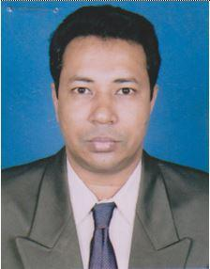 | DR. ABU HANNAN MOHAMMED MONIR AHMED  F/Name: Mohammed Abdur Rob  M/Name:  BM & DC Reg. No:  NID:  Cell:  Address: Feni Central Hospital, S S K Road, Feni.  Blood Group:
64 | Voter No  LM-1800064 | dR. MD. SHARIAT ULLAH MAJUMDER  F/Name: Md. Balal Hossain Majumder  M/Name: Murshida Begum  BM & DC Reg. No: 29255  NID:  Cell: 01716086912  Address: Feni clinic Younus Center S.S.K Road Feni  Blood Group: O+
65 | Voter No  LM-1800065  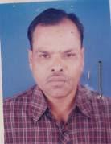 | DR. MD. MIZANUL KARIM SAMRU  F/Name: Late Fasiul Alam Miah  M/Name: Late Sycda Akter Mahal Begum  BM & DC Reg. No: 9748  NID: 3022910104968  Cell: 01711903509  Address: Azad Medical Hall Doctor Para Feni.  Blood Group:
66 | Voter No  LM-1800066 | dR. GAUTAM CHANDRA SAHA  F/Name: Bhushan Chandra Saha  M/Name: Prarthana Rani Saha  BM & DC Reg. No: 35312  NID: 3022903125209  Cell: 01711025000  Address: Hazi Fazler Rahman Vaban, 32 Academy Road, Feni  Blood Group: O+
67 | Voter No  LM-1800067  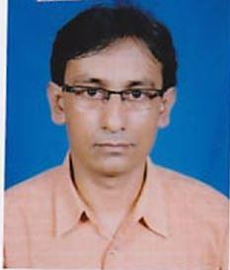 | DR. BIMAL CHANDRA DAS  F/Name:  M/Name:  BM & DC Reg. No:  NID:  Cell:  Address: “Altrapath” 42,Trank Road, Feni.  Blood Group:
68 | Voter No  LM-1800067 | DR. BIMAL CHANDRA DAS  F/Name:  M/Name:  BM & DC Reg. No:  NID:  Cell:  Address: “Altrapath” 42,Trank Road, Feni.  Blood Group:
69 | Voter No  LM-1800068 | DR. MD. MERAJUL ISLAM  F/Name: Abdul Aziz  M/Name: Zamila Khatun  BM & DC Reg. No: 21473  NID: 3022901116214  Cell: 01711387527  Address: Zannat Villa, Najir Road, Feni  Blood Group: A+
70 | Voter No  LM-1800069  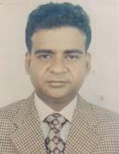 | DR. MD. DELWAR HOSSAIN  F/Name: Fakir Mohammad Sardar  M/Name: Sarvatar Nessa  BM & DC Reg. No: 24191  NID:  Cell: 01711816072  Address: UHC-Dagon Bhuiyan, Feni  Blood Group: B+
71 | Voter No  LM-1800070 | DR. MD. ZAHANGIR ALAM  F/Name: Md. Khurshid Ahamed  M/Name: Mrs. Rowshan Ara Begum  BM & DC Reg. No: 31449  NID: 1594116381232  Cell: 01716064771  Address: 583/1, Shaheen Academy Road, Feni  Blood Group: O+
72 | Voter No  LM-1800071  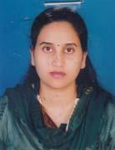 | DR. FERDOUS ARA BEGUM  F/Name: Ali Ahmed  M/Name: Lutfer Nahar Begum  BM & DC Reg. No: 50188  NID: 3022916163941  Cell: 01717308536  Address: 273, Old Police Quarter, S.S.K Road, Feni  Blood Group:
73 | Voter No  LM-1800072 | DR. KRISHNA PADA SAHA  F/Name: Late Gopi Nath Saha  M/Name: Late Anrua Prava Saha  BM & DC Reg. No: 26297  NID: 3022909143934  Cell: 01716021247  Address: Medical Officer, Feni Pourashava, Feni  Blood Group: B+
74 | Voter No  LM-1800073 | DR. SHAH MD. FAZLE RABBI  F/Name: Late. Md. Abdur Rob  M/Name: Momtaz Begum  BM & DC Reg. No: 39511  NID:  Cell: 01913631295  Address: Shamim Villa, Pathan Bari Road. Feni  Blood Group: B+
75 | Voter No  LM-1800074 | DR. GOLAM MOWLA  F/Name: Late Md. Syed Ullah  M/Name: Late Amena Begum  BM & DC Reg. No: 18885  NID: 3029403477637  Cell: 01711360200  Address: Ali Newaz Medical Centre 188, Trunk Road, Feni  Blood Group:
76 | Voter No  LM-1800075 | DR. MD. AZIZ ULLAH  F/Name: Abdul Jalil  M/Name: Amena Khatun  BM & DC Reg. No: 36179  NID:  Cell: 01913487334  Address: Sadar Hospital, Feni  Blood Group: O+
77 | Voter No  LM-1800076 | DR. MD. NASIRUDDIN  F/Name: Late Md. Khurshid Alam  M/Name: Hosneara Begum  BM & DC Reg. No: 17823  NID: 3025106811135  Cell: 01720232033  Address: Offi. UHC, Parashurram, Feni  Blood Group: O+
78 | Voter No  LM-1800077 | DR. GAZI GOLAM MOSTOFA  F/Name: Late Fazar Ali Gazi  M/Name: Rahima Khatun  BM & DC Reg. No: 26603  NID: 3022911112375  Cell: 01711988819  Address: Ali Newaz Medical Center, Trunk Road, Feni  Blood Group: B+
79 | Voter No  LM-1800078  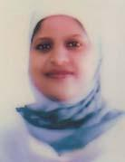 | DR. BEGUM SHAIRA SHARIFA  F/Name: Late Farid Uddin Ahmed  M/Name: Begum Momataz Sharifa  BM & DC Reg. No: 28955  NID: 3022911112393  Cell: 01711357991  Address: Ali Newaz Medical Centre, Trunk Road, Feni  Blood Group: B+
80 | Voter No  LM-1800079 | DR. MD. ABDUL. QUDDUS. SHOHAG  F/Name: Md. Abdul. Kader  M/Name: Rowshan Ara Begum  BM & DC Reg. No: 44475  NID:  Cell: 01711312161  Address: Vill- Kaikhali, P.O:- Sindurpur, P.S- Dagaonbhuiyan, Feni  Blood Group: O+
81 | Voter No  LM-1800080 | DR. MD. MUSA MEAH  F/Name: Md. Nurul Absar  M/Name: Mrs. Anwara Begum  BM & DC Reg. No: 26007  NID:  Cell: 01818806867  Address: Upazila Health Complex Chagalnaiya, Feni  Blood Group: B+
82 | Voter No  LM-1800081 | DR. MD. LUTFUR RAHMAN  F/Name: Late Abdul Halim Sarker  M/Name: Rahatun Nessa  BM & DC Reg. No: 25559  NID: 2691650136710  Cell: 01711-867627  Address: 19, West End Street, Central Road, Dhaka-1205  Blood Group: AB_po
83 | Voter No  LM-1800082 | DR. MD. SAIFUL ISLAM  F/Name: Late Md. Fazul Karim  M/Name: Muslim Ara Begum  BM & DC Reg. No: 34146  NID: 3022902120976  Cell: 01711-310499  Address: Daff Res. School, English Medicine, 2nd floor Comilla Bus Stand, Trunk Road, Feni  Blood Group:
84 | Voter No  LM-1800083  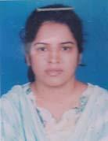 | DR. BANANI RANI MONDAL  F/Name: Nittyananda Mondol  M/Name: Ashalata Mondal  BM & DC Reg. No: 33685  NID: 3022918168280  Cell: 01720204111  Address: Nurnabi Bhavan, Cosmopolitan Road, Feni  Blood Group:
85 | Voter No  LM-1800084  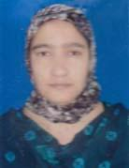 | DR. SADIA JABEEN KHAN  F/Name: Md. Jaynul Abedin Khan  M/Name: Nurun Nahar  BM & DC Reg. No: 28718  NID:  Cell: 01735354859  Address: Consultan Obs Guy Sonagaji, Feni  Blood Group: A+
86 | Voter No  LM-1800085 | DR. JALAL UDDIN MD. RUMI  F/Name: Sayeruzzaman Bhuiyan  M/Name: Mrs. Jahanara Begum  BM & DC Reg. No: 28681  NID:  Cell: 01716985666  Address: J. Consultent (Surgery) 250 Bed Feni, District Hospital  Blood Group: B+
87 | Voter No  LM-1800086 | DR. TASLIMA AKHTER  F/Name: Tazamul Hossain  M/Name: Shahida Akhter  BM & DC Reg. No: 18639  NID: 3022910105596  Cell: 01819957336  Address: 5A/J.K. Center, Panch-Gachia Road, Feni  Blood Group: A+
88 | Voter No  LM-1800087 | DR. GALIB MD. ASADULLAH  F/Name: A.k.m. Atiqullah  M/Name: Sultana Mariam Banu  BM & DC Reg. No: 49724  NID: 8524904042983  Cell: 01713077913  Address: Nasir Monzil, Pathan Bari Road, Feni  Blood Group: O+
89 | Voter No  LM-1800088  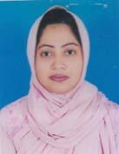 | DR. HASINA AKTER  F/Name: Md. Rahmot Ullah  M/Name: Mrs. Taj Nahar Khanam  BM & DC Reg. No: 34623  NID: 7528705133649  Cell: 01717033943  Address: Medical Officer TB Clinic, Feni  Blood Group: A+
90 | Voter No  LM-1800089 | DR. BRIG GEN GAZI ABU BAKAR  F/Name: Late Gazi Karim Bakshi  M/Name: Late Phool Jahan Begum  BM & DC Reg. No: 9765  NID: 1590698803501  Cell: 01719059890  Address: Feni Diabetes Hospital, Mizan Road, Feni  Blood Group: O+
91 | Voter No  LM-1800090  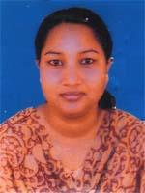 | DR. KAMRUN NAHAR  F/Name: Late Munshi Mozaffor Hossain  M/Name: Zinnatun Nessa  BM & DC Reg. No: 26241  NID: 3022911112315  Cell: 01712267933  Address: 368, S. S. K Hospital Feni  Blood Group: B+
92 | Voter No  LM-1800091 | DR. KHONDAKER ZAHIRUL HASAN  F/Name: Khondaker Habibur Rahman  M/Name: Rowshan Ara  BM & DC Reg. No: 31026  NID: 1913110530108  Cell: 01819128876  Address: Junior Consultant (Paediatrics) 250 Bed District Sadar Hospital , Feni  Blood Group: O+
93 | Voter No  LM-1800092 | DR. PRABIR KUMAR NATH  F/Name: Late Brajalal Nath  M/Name: Tulu Rani Bhowhik  BM & DC Reg. No: 35261  NID:  Cell: 01763218880  Address: 580 Postoffice Road, Feni  Blood Group: O+
94 | Voter No  LM-1800093 | DR. MD. SIKANDAR ABU ZAFAR  F/Name: Md. Idrilia Ali Molla  M/Name: Razia Sultana  BM & DC Reg. No: 33006  NID: 19733022910105897  Cell: 01716196170  Address: 291/01, 9A, Feni Tower, SSk Road, Feni  Blood Group: A+
95 | Voter No  LM-1800094  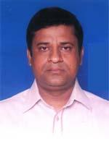 | DR. MOHAMMAD ELIAS BHUIYAN  F/Name: Mohammad Ishaque Bhuiyan  M/Name: Anwara Begum  BM & DC Reg. No: 37742  NID: 1913110534642  Cell: 01712189609  Address: Medical officer , Civil Surgeon office, Feni  Blood Group: O+
96 | Voter No  LM-1800095  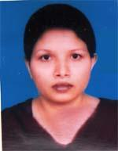 | DR. KAMRUN NAHAR  F/Name: Abdur Rashid  M/Name: Farida Khatun  BM & DC Reg. No: 36423  NID: 3022916164012  Cell: 01711458345  Address: Karim Tower, S.S.K. Road, Feni  Blood Group: O+
97 | Voter No  LM-1800096  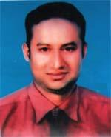 | DR. MOHAMMAD KAMAL UDDIN  F/Name: Nur Mohammad  M/Name: Jahanara Begum  BM & DC Reg. No: 39625  NID: 1594309885272  Cell: 01711303602  Address: Feni Sadar Hospital, Feni.  Blood Group: O+
98 | Voter No  LM-1800097 | DR. NAZMUL HAQUE MUNNA  F/Name: Enamul Hoque  M/Name: Selina Begum  BM & DC Reg. No: 40822  NID: 2697556419327  Cell: 01933505407  Address: Abakash Puraton Police Quarter, Post+Thana+Dist-Feni  Blood Group: O+
99 | Voter No  LM-1800098  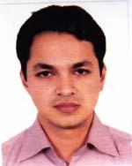 | DR. MOHAMMAD HAROON OR RASHID  F/Name: Mohammad Abdur Rouf  M/Name: Loliua Begum  BM & DC Reg. No: 41214  NID: 2691648032988  Cell: 01717427073  Address: Doctor Para, Pathan Bari Road, Feni  Blood Group: O+
100 | Voter No  LM-1800099 | DR. ROKSANA BEGUM  F/Name: Md. Abul Kashem Bhuiyan  M/Name: Rasheda Begum  BM & DC Reg. No: 41406  NID: 2697556373061  Cell: 01714324750  Address: Flat No. 701, Master Tower, SSK road, Feni, Mo, Sadar Hospital, Feni  Blood Group: B+
101 | Voter No  LM-1800100 | DR. MUHAMMAD SAIYEDUR RAHMAN  F/Name: Muhammad Ali  M/Name: Halima Khatun  BM & DC Reg. No: 41407  NID: 2697556373062  Cell: 01716628844  Address: Resident Physician, 250 Beded District Sadar Hospital, Feni  Blood Group: B+
102 | Voter No  LM-1800101  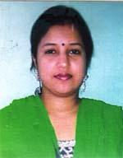 | DR. SEEMA RANI MAJUMDER  F/Name: Narayan Chandra Majumder  M/Name: Sabita Rani Raha  BM & DC Reg. No: 45482  NID: 2691649122722  Cell: 01717298678  Address: Hazi Clinic Dagonbhuiyan, Feni  Blood Group: B+
103 | Voter No  LM-1800102  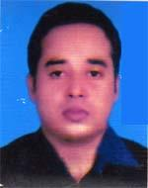 | DR. IQBAL HOSSAIN BHUIYAN  F/Name: Joynal Abedin Bhuiyan  M/Name: Mymuna Begum  BM & DC Reg. No: 50156  NID: 2696654368192  Cell: 01712167281  Address: Upazilla Health Complex, Chhagolnayia, Feni  Blood Group: B+
104 | Voter No  LM-1800103 | DR. MOHAMMAD KHURSHID ALAM  F/Name: Abdur Rashid  M/Name: Anwara Begum  BM & DC Reg. No: 50328  NID: 6125217234690  Cell: 01740944311  Address: MO, (Anaest) 250 Bed, Sadar Hospital , Feni  Blood Group: B+
105 | Voter No  LM-1800104  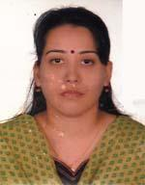 | DR. KAZI SHANZIDA AKTER  F/Name: Kazi Shafiqur Rahman  M/Name: Kazi Nazma Shafiq  BM & DC Reg. No: 48202  NID: 0695112194186  Cell: 01751554061  Address: Medical officer, Sharishadi Sub quater, Feni Sadar, Feni  Blood Group: A+
106 | Voter No  LM-1800105  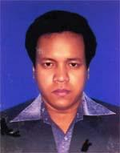 | DR. MD. ABDULLAH ABBASI  F/Name: Md. Abu Taher  M/Name: Nilu Ara Begum  BM & DC Reg. No: 52260  NID: 3022902122462  Cell: 01716255589  Address: 221, East Master Para, Feni  Blood Group: O+
107 | Voter No  LM-1800106  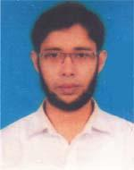 | DR. ARMAN BIN ABDULLAH  F/Name: A. B. M. Abdullah  M/Name: Rowshan Akter  BM & DC Reg. No: 49491  NID: 19844798516214983  Cell: 01911064129  Address: 3/C, Belal Mension, Pathan Bari Road, Feni  Blood Group: A+
108 | Voter No  LM-1800107 | DR. S. S. R. MASUD RANA  F/Name: Mafizur Rahman  M/Name: Jahan Ara Begum  BM & DC Reg. No: 51179  NID: 2617272345311  Cell: 01717571508  Address: UHC, Feni Sodar, Feni  Blood Group: AB+
109 | Voter No  LM-1800108  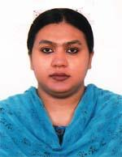 | DR. SABINA YESMINE  F/Name: Md. Rafiqul Alam Chowdhury  M/Name: Khodeza Khanam  BM & DC Reg. No: 50672  NID: 9196211231572  Cell: 01741779944  Address: Baitul Kamal, 1st Floor, West Ukilpara, Sadar, Feni  Blood Group: B+
110 | Voter No  LM-1800109  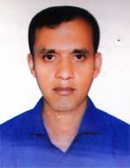 | DR. MD. KAMRUZZAMAN  F/Name: Md. Sana Ullah  M/Name: Khalada Khatun  BM & DC Reg. No: 50676  NID: 2691649459740  Cell: 01815003584  Address: 49/2, S. S. K. Road, Feni, Master Tower  Blood Group: A+
111 | Voter No  LM-1800110 | DR. MD. REAZ UDDIN CHOWDHURY  F/Name: Late Main Uddin Ahmed  M/Name: Anowara Begum Chowdhury  BM & DC Reg. No: 48201  NID: 0695111184784  Cell: 01717407412  Address: Medical officer, Sadar Hospital Feni.  Blood Group: B+
112 | Voter No  LM-1800111  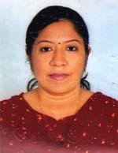 | DR. CHANDRIMA CHOWDHURY  F/Name: Nitish Chandra Chowdhury  M/Name: Shikha Das Chowdhury  BM & DC Reg. No: 49340  NID: 2696352235939  Cell: 01717441856  Address: Flat No. 10C, 9th Floor, Hazilatif Tower, Feni  Blood Group: n_a
113 | Voter No  LM-1800112  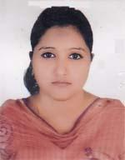 | DR. ZARZIS ANAR  F/Name: Md. Amirul Islam  M/Name: Mrs. Rahima Islam  BM & DC Reg. No: 51350  NID: 19840695112193457  Cell: 01741738364  Address: Khan Monjil, House No. 619, Holding No. 21, Foleshwer, Feni  Blood Group: O-
114 | Voter No  LM-1800113  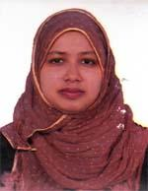 | DR. FAHMIDA YESMIN  F/Name: Abdur Rouf Bhuiyan  M/Name: Nasima Akter  BM & DC Reg. No: 53078  NID: 2696536937586  Cell: 01670491561  Address: Medical Officer, Sadar Hospital Feni.  Blood Group: B+
115 | Voter No  LM-1800114  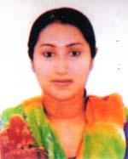 | DR. NAZIA GOFRAN  F/Name: Abdul Gofran  M/Name: Setara Gofran  BM & DC Reg. No: 52662  NID: 2690243845063  Cell: 01812213803  Address: 49/2, S.S.K. Road, Feni, Master Tower  Blood Group: A+
116 | Voter No  LM-1800115  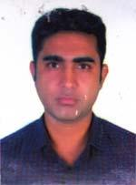 | DR. ABU TAHER  F/Name: Abul Khair  M/Name: Sufia Akhter  BM & DC Reg. No: 62410  NID: 9196201102495  Cell: 01775102633  Address: East Alaq, Patwary Bari, Feni  Blood Group: O+
117 | Voter No  LM-1800116 | DR. SIRAJUL MUNIR OHI  F/Name: Jafar Ahmed Hanafi  M/Name: Helena Afroza  BM & DC Reg. No: 53484  NID: 3012512584344  Cell: 01976278201  Address: 250 Bed District Sadar Hospital, Feni  Blood Group: B+
118 | Voter No  LM-1800117 | DR. MORJINA BEGUM  F/Name: Mr. Md. Siddiqur Rahman  M/Name: Kamrun Nahar  BM & DC Reg. No: 61549  NID: 19881022014000019  Cell: 01761292754  Address: Medical officer, Sadar Hospital Feni  Blood Group: O+
119 | Voter No  LM-1800118 | DR. SUPRIYA SARKER  F/Name: Suresh Chandra Sarker  M/Name: Shamoli Sarker  BM & DC Reg. No: 61792  NID: 9196203131363  Cell: 01840392631  Address: Flat No. 1F, Nakshi Palace, 14/Ka/02, Nowab Habibullah Road, Dhaka.  Blood Group: n_a
120 | Voter No  LM-1800119 | DR. TASMIA MAZUMDER  F/Name: Alauddin Mazumder  M/Name: Dr. Taslima Akhter  BM & DC Reg. No: 61841  NID: 19892924703122636  Cell: 01711572491  Address: 5/A, J. K. Centare, Road, Feni  Blood Group: A+
121 | Voter No  LM-1800120 | DR. MD. MOMINUL ISLAM KHAN  F/Name: Md. Solaiman Khan  M/Name: Khodeja Begum  BM & DC Reg. No: 71807  NID: 6897636343  Cell: 01820133552  Address: vital Research, Unit-1; Amin manjil, Puratan Sonagazi Bus Stand, Trunk Road, Feni.  Blood Group: A+
122 | Voter No  LM-1800121 | DR. MUHAMMAD JAHANGIR KABIR  F/Name: Shekendar Ali  M/Name: Firoza Begum  BM & DC Reg. No: 38791  NID: 2690815059635  Cell: 01739779779  Address: National Medical, College, Feni  Blood Group: O+
123 | Voter No  LM-1800122 | DR. MD. HEDAYET ULLAH  F/Name: Late Abul Khair  M/Name: Mrs. Meher Necha  BM & DC Reg. No: 30883  NID: 3022909144047  Cell: 01712062133  Address: Al Amin Lane, Sadar Hospital, Feni  Blood Group: B+
124 | Voter No  LM-1800123 | DR. MIR IFTEKHAR MOSTAFIZ  F/Name: Mir Mostafiz Ahmed  M/Name: Nargis Mostafiz  BM & DC Reg. No: 36986  NID: 2691649107770  Cell: 01911640389  Address: Chest Disease Clinic, Feni (Consultant)  Blood Group: A+
125 | Voter No  LM-1800124  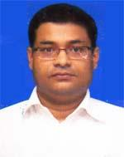 | DR. ASHIM KUMAR SAHA  F/Name: Late Nirandan Prasad Saha  M/Name: Pratima Saha  BM & DC Reg. No: 30540  NID: 3022901114937  Cell: 01820257084  Address: RMO. District Sadar Hospital, Feni  Blood Group: B+
126 | Voter No  LM-1800125  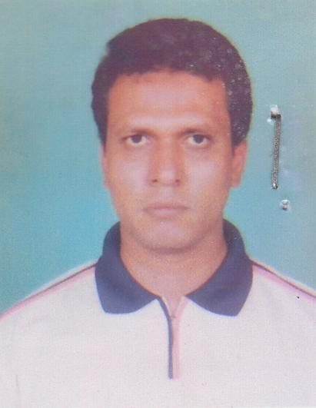 | DR. FORHAD HOSSAIN CHOWDHURY  F/Name: Sala Ahmed Chowdhury  M/Name: Khairunnessa  BM & DC Reg. No: 29774  NID: 3014181689971  Cell: 01711949570  Address: N/A  Blood Group: A+

